**Title**

Author name1, Author name2, (The name of the presenter should be bolded and underlined)

*1Author’s affiliation and full address: 12 point type, centered, italicized*

*2Author’s affiliation and full address: 12 point type, centered, italicized*

*Presenter’s e-mail address: 12 point type, centered, italicized*

**Abstract**xxx

**Keywords**xxx

**Introduction** xxx

**Experimental** xxx

**Results and Discussion** xxx

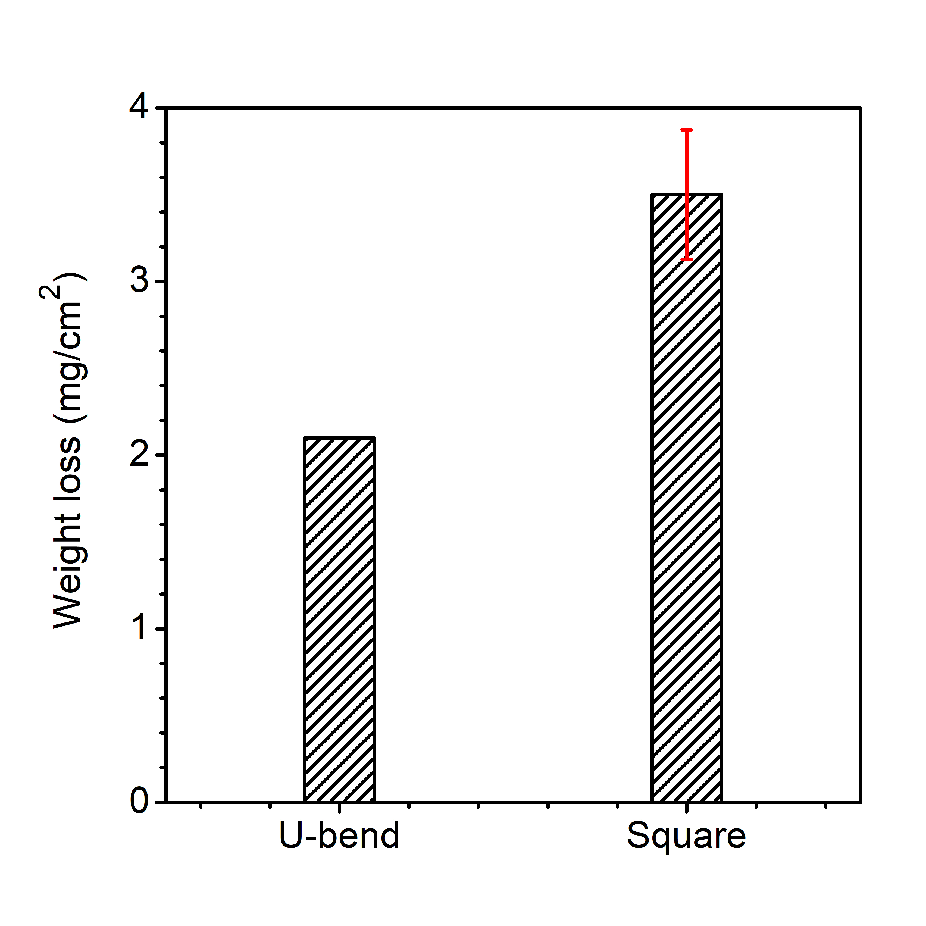

**Figure 1** The weight losses square coupon after a 14-d incubation in an anaerobic culture medium with *D. vulgaris*.

**Table 1** Fitted parameters of EIS with different LJ concentrations and temperatures.

|  |  |  |  |  |  |  |
| --- | --- | --- | --- | --- | --- | --- |
| *T* (K) | *C*LJ (mg/L) | *R*s (Ω cm2) | *Q*dl (Ω-1 sn cm-2) | n | *R*ct (Ω cm2) | *η* (%) |
| 303 | 0 | 0.44 | 8.64×10-4 | 0.82 | 6.98 | — |
| 50 | 0.48 | 6.98×10-4 | 0.80 | 11.8 | 41 |
| 100 | 0.57 | 7.18×10-4 | 0.78 | 14.8 | 53 |
| 323 | 0 | 0.37 | 7.43×10-4 | 0.86 | 3.89 | — |
| 200 | 0.33 | 7.70×10-4 | 0.79 | 13.8 | 72 |
| 300 | 0.41 | 5.05×10-4 | 0.80 | 15.0 | 74 |

**Conclusion** xxxxx

**Reference (followed the APA 7th)**

[1] xxx

[2] xxx

[3] xxx